**Stats Investigation**

**Question 1: Indigenous population comparison**

**Indigenous Histogram**

1. Use the given data to construct a Histogram for the population of Indigenous people in Australia in 2011

1. Which age group contained the most Indigenous people? 0-4 years old
2. Describe the shape of the histogram. Is it symmetrical or skewed? The graph is positively skewed.

**Non-Indigenous histrogram**

1. Use the given data to construct a Histogram for the population of Indigenous people in Australia in 2011

1. Which age group contained the most non-Indigenous people? 65 years and older
2. Describe the shape of the histogram. Is it symmetrical or skewed? The graph is symmetrical other than the outlier of the 65 and older population

**Comparisons**

1. Explain the main difference in the shapes of the two histograms. The indigenous population graph seems to steadily drop as the population gets older, whereas the non-indigenous population is pretty much the same until it skyrockets at the 65 and older population
2. What do the histograms tell you about the age of Indigenous and non-Indigenous people in Australia in 2011? We have mostly younger Indigenous people in Australia and mostly older non-indigenous people
3. What do the histograms tell you about the difference in life expectancy for Indigenous and non-Indigenous people in Australia in 2011? The life expectancy seems to be much less for the Indigenous population when compared to the non-Indigenous people.

**Question 2: Antarctic Ice**

**Data Interpretation**

1. By how much did the Antarctic ice mass increase in:
2. 2007 – By 450 gigatonnes
3. 2010 – By 200 gigatonnes
4. By how much did the Antarctic ice mass decrease in:
5. 2011 – By 100 gigatonnes
6. 2014 – By 700 gigatonnes
7. What was the overall change in ice mass from the beginning of 2010 to the end of 2012?

The overall ice mass decreased by 1200 gigatonnes from 2010 to 2012

**Time-series plot**

1. Construct a time-series plot for the given data

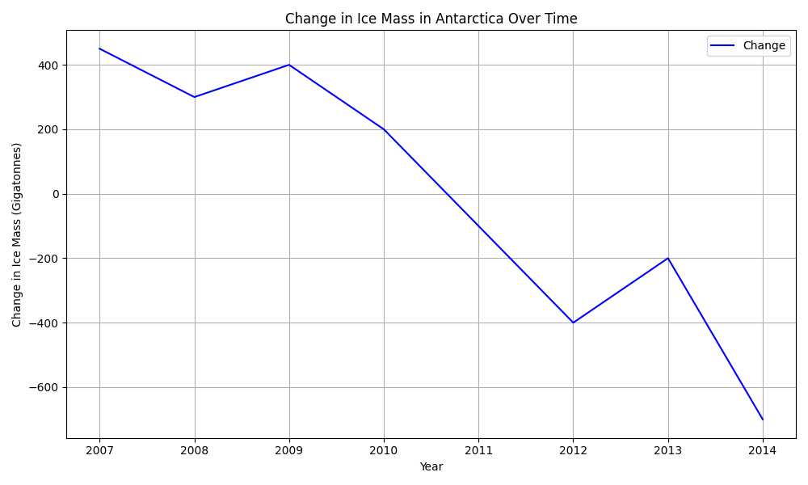

1. The change in ice mass has been decreasing fast and the overall ice mass has been decreasing since 2011

**Line of best fit**

1. Fit a line of best fit by eye to your time series plot (use the points (2008,450) and (2013, -500).

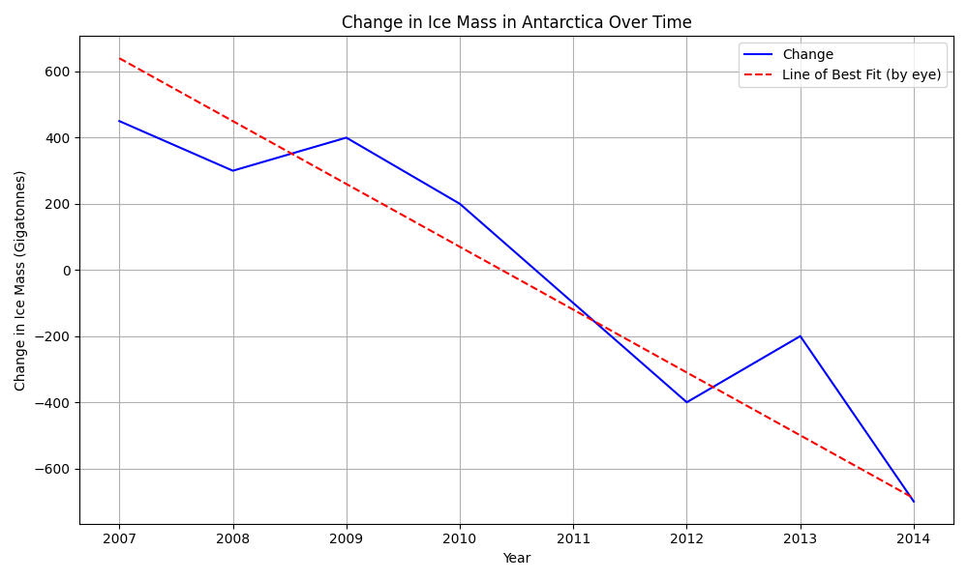

1. Find an equation for your line of best fit.
2. Use your equation to estimate the change in ice mass for:
3. 2015 –
4. 2025 –

**Regression**

1. Use technology to find the least squares regression line for your time-series plot.

1. The line of best fit has a steeper gradient and starts higher, the difference in slopes means the line decreases more sharply than the regression line.